ADP eLearning Course – Proposed Modification
Umair Qureshi
Athabasca University

Proposed Modification – ADP eLearning Course
Discussion Forums for ADP Clients Courses

December 9, 2012

Director of Learning Services
ADP
Toronto, Ontario

Dear Director of Learning Services,

We are requesting that Discussion Forums be utilized in ADP's course for ADP eLearning Course. We believe that this request fits very well with Learning Services objective of delivering engaging training to its clients.

Learning Services offers a number of excellent courses, both synchronous and asynchronous, in multiple modes such as face-to-face, eLearning, and blended. The addition of discussion forums to ADP eLearning Course will act as a benchmark and beacon for other courses that Learning Services offers to ADP Clients.

With this added technology to ADP eLearning Course, clients will be more engaged in the training and be able to share their experiences and knowledge with other clients. It will allow for problem solving capabilities among clients as they share their problem-solution situations with the course content and build a knowledge base that can be used by anyone enrolled into the course. And the potential offered by the discussion forum feature in ADP eLearning Course is immense and critical to all other courses offered by ADP Learning Services, as the discussion forum feature can be further added into other courses and its benefits will be far reaching.

Please review the proposal offered in this document. We look forward to a positive response on this matter.

Sincerely,

Umair Qureshi
Instructional Designer, ADP Learning Services

Statement of the Problem
Having a discussion forum as part of a course can produce very powerful results from the perspective to learning. A discussion forum can add significant value by allowing clients in a course to participate in open ended discussions and as a result produce a knowledge base for future clients or students. ADP eLearning Course is a prime example of solid a standalone eLearning course which is missing some engagement and interaction attributes to it. By adding a discussion forum to this course, ADP can add the missing attributes of interaction and engagement which will allow participants to reiterate and reinforce their learning. A solution to this problem is the addition of the discussion forum to the course. The proposal is to make change happen to this course, managing the change, discussion of benefits of having discussion forums, a full implementation and evaluation plan for the discussion forum for the course in question.
Proposed Solution

An analysis of ADP eLearning Course is carried out in Appendix A, which identifies various strengths and weaknesses within the course. In addition, some general recommendations from it have been used to develop a solution to the problems identified. The proposed solution to the problem will be to implement a discussion forum in the course which will allow for more interactive and engaging experience for the clients of ADP taking the course. Examples of a discussion forum and sample communications within it are located in Appendix C. And an example of the actual layout and design of the course are located in Appendix B.
Organizational Change

Change will be a critical part of implementing a discussion forum as it is a new technology and is rarely used by ADP and its clients with respect to the training ADP offers. We will consider the method of changing the approach to delivering training and then how various stakeholders will adopt the technology. Change is not an easy task in an organization, especially when it is a drastic change. In order for change to be effective and sustainable, certain steps and tasks need to be implemented.

Unfreezing
ADP's course is operating to a certain degree in a satisfactory way and there are a large number of students taking the course. However, the survey results from the students are not showing high level of satisfaction, and this is frustrating for the staff of the Learning Services department. As a result, all of Learning Services are aware that change must take place with this specific course so there is a will to change for the way the course is delivered.
Transitioning
In order for the transition to be successful it must be performed properly. Getting a discussion forum implemented in the course and students to be effectively utilizing it, must be followed with proper instructions and a method of grading for it. So what this means is that a set of instructions must be provided to the students enrolled in the course, as to what they must do in order to effectively participate in the discussion forum. In addition, ADP's staff that is supporting the forum must be educated as well about the functionality of the discussion forum and the ability to monitor it.
Once the discussion forum is active, students will be engaging with each other and their activity in the forum will be tracked through the Learning Management System (LMS). Essentially, the goal is ideally to utilize more discussion forums across the courses offered by Learning Services. So the success of the transition is very important to the success of discussion forums in general for ADP.
Refreezing
Once the transition is completed, a refreezing must take place of the way the discussion forums are utilized in the course. Then the results of the discussion forum usage in the course must be examined to be implemented in other courses. This however, will be a separate project.
What qualities make a technology adoptable? Well, it is combination of factors, which are discussed below. We will consider these factors with respect to the adaptability of discussion forum with ADP’s current infrastructure and its future plans. Generally, ADP Learning Services are looking towards incorporating social networks across its training and allowing clients to communicate with each other to share problems/resolutions. As part of this outlook, the discussion forum is a great stepping stone.

Relative Advantage
Students should also be given an opportunity to communicate with each other via discussion forums. The only problem with this however is that this is a standalone course, so it will be difficult to establish such asynchronous modes of communications between students (Simpson, 2002). Just because students are in an asynchronous course, doesn’t necessarily mean that they cannot communicate with each other. Students can use social networking type tools of the LMS that ADP uses for its clients.
Compatibility with existing values and practices
The discussion forums feature is already available in the LMS that ADP’s clients’ use, so it will not be difficult or a lot of change management will not be required to perform this task.
Simplicity and ease of use
The discussion forums feature si very easy to use and students are likely to eb already familiar with them.
Trialability
Discussion forums can be adopted in the course in question, and this will allow ADP to test out the success of the tool with its clients.
Observable Results
The results of the discussion forum postings and replies can be measured by the LMS because they are always tracked.
According to Everett Rogers, these five qualities determine between 49 and 87 percent of the variation in the adoption of new products.
Reinvention
Depending on the success of the discussion forum in the course, they can be extended to other courses and allow ADP to build a social network of its’ clients population. The potential offered by the discussion forums is massive as ADP can then use the success of these to develop a client social network.
Innovators
The innovators of the discussion forums will be the first course that utilizes them and based on the success discussion forums can then be extended to more courses. In addition, the coordinators of ADP’s Learning Services department will also have to become innovators, as they will be responsible for supporting the discussion forums and ensuring the postings and replies are of quality.
Early Adopters
The early adopters will be the Instructional Designers of Learning Services that will promote the discussion forums and will know the benefits of using discussion forums in a course. These individuals will be critical in the push for discussion forums being adopted by the entire Learning Services department.
Early Majority
The key individuals that will be early majority will be instructors of Learning Services, who are not very tech savvy however, do appreciate any success in improved education delivery to ADP’s clients. The instructors will promote the discussion forums directly to the clients and so it must be ensured that the instructors are aware of the discussion forums really well and will have a generally positive outlook of them.
Another group of individuals will be other clients that are getting training from ADP. And as the discussion forums’ phenomenon grows in ADP Learning Services team, other courses will begin to use discussion forums as well and the clients using other courses will be the early majority.
Late Majority
The late majority individuals will be the remaining ADP associates that engage with clients. In this instance, they will be from departments like Sales who bring in new clients and Implementation Specialist Teams who setup a brand new client with ADP. In addition, the new clients will be the late majority as well since they will be taking ADP courses that have discussion forums.
Laggards
It is difficult to anticipate who the laggards will be in a situation like this, since we are not implementing a new system, rather we are simply turning on a feature of a LMS. However, it we were to identify a group of individuals then it would have to be the clients who aren’t very tech-savvy or are not comfortable communicating or sharing information over discussion forums. In addition, other reasons can be that those clients simply do not have time to use participate in the discussion forum(s), let alone complete the actual course (A summary of Diffusion of Innovations, 2009).
Benefits of using Discussion Forums
- Builds connections and class community by promoting discussion on course topics and more informal discussions.
- Contributes to the development of cognitive, critical thinking, and writing skills
- Allows time for thoughtful, in-depth reflection on course topics. Much like traditional writing exercises, students have more time to think about, research, and compose their thoughts before contributing to the discussion.
- Facilitates exploratory learning by allowing students to review and respond to the work of others and approach learning in diverse ways
- Empowers students to express themselves. For students with different learning styles, an discussion forum can be a venue where they feel more comfortable contributing to group discussions. With positive reinforcement on the discussion forum, an increase in class participation may also occur (Mastering Online Discussion Board Facilitation, 2010).
Implementation and Evaluation
Task | Resource(s) | Deadline
Create a how to guide for discussion forums in the LMS | Coordinators | January 10
Create Rules of the do's and don'ts of discussion forums | Instructional Designers | January 10
Notify all course participants of the upcoming discussion forum activation in the course | ADP Learning Services Coordinators | January 20
Activate Discussion Forums | Coordinators | February 4
Once forum is active, encourage clients to participate in the discussion forums by actively engaging with them | One instructor assigned to administer the discussion forum | February 10 (ongoing)
Measure student activity in the discussion forum for one month, use this as a benchmark | Learning Analyst | March 4
Measure the second, third, and fourth months' activities in discussion forum then compare with benchmark | Learning Analyst | April 4, May 4, and June 4
Have instructional designers promote the discussion forum technology of the LMS throughout ADP | Instructional Designers | May 4
Have instructors promote the discussion forum to ADP clients in their face to face training sessions | Instructors | June 4
Evaluate the effectiveness of the discussion forum and the context of the discussions | Learning Analyst | June 10
Timelines for Discussion Forums Implementation (All dates for 2013)

Best Practices
- Establish and communicate discussion board ground rules. What are your expectations for writing styles in the online forum? Are students expected to adhere to general rules of etiquette or does anything go? Including an introductory post that outlines your expectations for students will benefit you and your students.
- Determine and communicate how you will evaluate students’ participation. Students must know how their contributions will be assessed in order to make effective responses other; they may misunderstand your directions or become unsure of what is expected of them, which can lead to a frustrating and ineffective learning experience.
  - What are your guidelines for giving students credit for discussion board participation? Do they need to post a certain number of times? How often? Any specific length? Is there information they should include or reference? What are your specific evaluation criteria?
  - Encourage students to contact you if they don’t understand the assignment or are having technical difficulties with the board.
- Engage your students by asking good questions to get discussions going. Use open ended questions and questions that challenge thinking. In depth guidelines for writing good discussion prompts are included in the Additional Resources section below.
- To encourage informal interaction and connection amongst your students, create an area in your discussion board for personal introductions and discussions. Your students may learn more about their peers than they would in the classroom, opening new doors of connection and community.
Conclusion
Throughout this proposal, we reviewed the discussion forums that ADP can implement as part of the eLearning Course it offers its clients. The course is offered in eLearning format and is self paced. eLearning isn’t the best mode of education delivery due to its isolation of the student from fellow students and an instructor. However, if it is the only alternative available to an organization, it is better than nothing. As a result, rather than changing the actual course design, delivery method, or content, it is recommended that a course discussion forum be incorporated that can add significant value in engagement and interaction for all client users enrolled in it.

References
A summary of Diffusion of Innovations. (2009). Retrieved on December 5, 2012, from http://www.enablingchange.com.au/Summary_Diffusion_Theory.pdf
Example of Moodle Discussion forum. (2006). Retrieved on December 5, 2012, from
http://www.d.umn.edu/~hrallis/professional/presentations/cotfsp06/indiv_tools/moodlescreenshot.html

Mastering Online Discussion Board Facilitation. (2010). Retrieved on December 6, 2012, from http://www.edutopia.org/pdfs/stw/edutopia-onlinelearning-mastering-online-discussion-board-facilitation.pdf
Appendices
Appendix A
Course Modification – ADP eLearning Course
Introduction
This paper will analyze a course that ADP has developed to train new clients on a newly developed product that ADP is offering. The course is delivered in eLearning format and teaches clients how to use ADP’s new product to manage their employees. Following the analysis, there will be some technology related modifications that will be proposed.
About ADP
ADP offers a wide range of human resources, payroll, tax and benefit administration solutions from a single source.
Students
Demographics
Students are adults who work for clients of ADP. They range from experience in the use of the payroll product that ADP delivers and their knowledge of payroll in general. Students’ age range is from 22 to 60 years of age. Therefore, all students are in the workforce. The technology used to deliver for the most part is available to all clients.
Access
Accessing the course is done through the Internet, via ADP’s client Learning Management System (LMS). As a result, access to high speed Internet and an appropriate browser are a requirement. All students have this access at their work locations. ADP wants all clients to have access and adopts the policy of Accessibility for Ontarians with Disabilities Act (AODA). ADP trains all its associates servicing Ontario clients to provide appropriate service to the clients following the standards of AODA.

Differences with respect to learning with technologies
Not all students are very tech savvy. Students’ skills with respect to using technologies are from excellent to average. However, we assume that students have sufficient technical skills to be able to successfully take the training.
Technologies required by students – Students must have a computer, a current browser, flash player, and speaker/earphones capabilities. Without all four of those pieces, the training will not be accessible. This is because the education is delivered via a distance.
Ease of Use
Computer and Information Technology
Assuming that the students have appropriate technology access, the eLearning has minimal learning curve. The students are obviously required to have a basic set of literacy skills and instructions in taking the eLearning course and how to maneuver within the eLearning are provided at the beginning of the course.
Orientation
At the moment, there is no specific timeframe that has been calculated or decided upon to claim that no more than certain amount of time should be taken by a brand new client to launch the course.
Interface Design
See screenshots of the ADP eLearning Course in Appendix 1.
Reliability
All information that the student enters is tracked and stored into the system. For example, while the eLearning is launched and suddenly crashes or closes, the LMS will remember where the student stopped and the next time the student launches that eLearning, it will begin from that point on. Additionally, all the information such as quizzes and other responses that the student entered are recorded and used for grading purposes.
Technical Support
Clients are provided with a phone number and email address to connect with in case of any issues that they may experience. During business hours they get a live Client Support Representative, and any inquiries after hours are resolved the following business day.
Costs
Designers and Software Licensing
Designing the course costs labour from Instructional Designers at ADP and the resources that these designers use. The software that they use such as Adobe Captivate, Photoshop, etc requires licenses, which cost annual fees.
Learning Management System (LMS)
The client Learning Management System has an annual licensing fee that ADP pays for.
Support Staff
These costs are the labour costs for the support staff such as Client Service Representatives.
Other Costs
Other costs include utilities that ADP pays for to support the Associates involved in creating the eLearning training. These costs can include Internet access, Laptop Licensing fees, Power, Office space Rent, etc.
Teacher
There is no teacher in class, so no costs associated with an instructor are involved. This is a self paced training course, offered online.
Note: Exact dollar values of these costs are not available at the moment.
Teaching and Learning
Epistemology and Selection of Technology
The course includes various simulations, audio, and text. In addition, various graphics are used to make the eLearning more engaging. See Figure 7 screenshot in Appendix 1 for an example of the simulation.
Content and Skills
The content provided in the eLearning is human capital management related, which encompasses Payroll, Human Resources, Recruitment of Employees, and Time & Attendance tracking. The focus is on a product the company offers its clients and how the clients will use it. The course teaches clients to use the product to manage their employees. The skills that the client needs to have prior to taking the course is knowledge in relation to payroll, human resources, and time & attendance. This means that the course doesn’t teach the client about the basics of HR or Payroll or Time & Attendance, rather it means that it teaches them to perform these tasks using the product that ADP offers. So in essence the perquisite is to have prior knowledge and understanding of the topics. This also includes knowledge of the Canada Revenue Agency’s Legislations and Canadian Labour Laws. Typically, students that are already practicing in Human Resources may be focused on the Human Resources part of the course, while students that focus on Payroll related tasks are focused on Payroll related tasks of the course. Essentially, students need to comprehend how to utilize the product that ADP is offering to manage their human capital.
Student Assessment Strategies
According Kirkpatrick’s five levels of training evaluations, ADP’s focus on evaluations is on levels 1 and 2 at present. Reaction, where the trainers carry out a survey at the end of the course from the clients to see what could have been improved upon in the course. And level 2, learning, where quizzes are taken by the students during the eLearning course that measure the student’s understanding of the actual course material. Beyond this, there is no official evaluation that is carried out. Surveymonkey is used for the surveys, and quizzes are embedded within the eLearning course (Simonson, Smaldino, Albright, & Zvacek, 2011).
Interaction and Interactivity
Interaction between learners and learning materials
Most of the interaction when the students are taking the eLearning is one way where information is fed to the student, with the aid of various media (graphics, simulations, etc). There is synchronous interaction that takes place when the student takes a quiz during the eLearning, and feedback is provided right away.
Learning as a social activity
There is no social interaction amongst students, student and teacher, etc. The interaction takes place between the student and the eLearning (computer generated).
The quality of interaction
The quality of interaction isn’t the greatest, and that is merely due to the design of the course. The most engaging aspect of the course is the quizzes, where feedback is provided and the quality of the feedback is designed by the Instructional Designers.
Organizational Issues
Organizational Support
Presently, the eLearning course is supported by the Client Service Representatives (CSR) who responds to phone calls and emails by clients. These Representatives are supported by the Instructional Designers who are the originator of the training. In addition, the CSRs also support the LMS that the clients use; therefore, any technical issues that clients experience are potentially resolved by the CSRs.
Novelty
The method of delivery of the eLearning course and the technologies involved in making it and delivering has been tested and most clients are able to take the eLearning course. The innovation really involves the actual design and development of the course, where the Instructional Designers incorporate different techniques in creating and presenting the content. The course content on the other hand is all new, as it is based on a new product that ADP has developed and is selling to its client.
Speed
Any changes to ADP’s product that are part of the training must be incorporated immediately as this is the means of informing the clients on how to use the product. There are updates to the product that take place on a regular basis; therefore, a significant amount of maintenance time is required from the Instructional Designers to implement these updates into the eLearning course. At this point, no one other than the Instructional Designers is familiar with the process and knowledge involved in updating the course.
Proposed Modifications
Interaction between learners and learning materials
There should be interactive simulations in addition to the demonstration simulations. The purpose of this will be to allow for behaviour level of evaluation to some extent. For example, after demonstrating performance of a task, have the student perform the same task with different steps (Simpson, 2002).
Learning as a social activity
Because there is no social interaction in the eLearning course, there should be some sort of communication means established by assigning an instructor to the course. Perhaps the instructor will act as a support mechanism if students have content related questions. The instructor needs to be more committed.
Students should also be given an opportunity to communicate with each other via discussion forums. The only problem with this however is that this is a standalone course, so it will be difficult to establish such asynchronous modes of communications between students (Simpson, 2002).
The quality of interaction
As mentioned in the learner and learning materials interaction modification, the quality of interaction needs to improve. A more rigorous and thorough testing means need to be incorporated to really validate the learning of the students. Additionally, appropriate technologies need to be utilized to allow for this (Simpson, 2002).
Conclusion
Throughout this paper, we reviewed a course that ADP offers its new clients that are using ADP’s new product. The course is offered in eLearning format and is self paced. The SECTIONS model was used to analyze the course and recommend how technologies can be used to make improvements to it (Bates, 2003). The eLearning isn’t the best mode of education delivery due to its isolation of the student from fellow students and an instructor. However, if it is the only alternative available to an organization, it is better than nothing. For the eLearning course that was analyzed, the course can use some interactivity additions as mentioned in the proposed modifications.

References
Bates, A. W., & Poole, G. (2003). A framework for selecting and using technology. In Effective
teaching with technology in higher education (pp. 75-105). San Francisco: Jossey Bass.
Simonson, M., Smaldino, S., Albright, M., & Zvacek, S. (2011). Teaching and Learning at
a Distance: Foundations of Distance Education (5th ed.). New York: Pearson.
Simpson, O. (2002). Supporting Students in Online, Open and Distance Learning (2nd ed.). New
York: RoutledgeFalmer.

Source: (Assignment 1, ADP eLearning Course – Recommended Modifications, 2012)

Appendix B

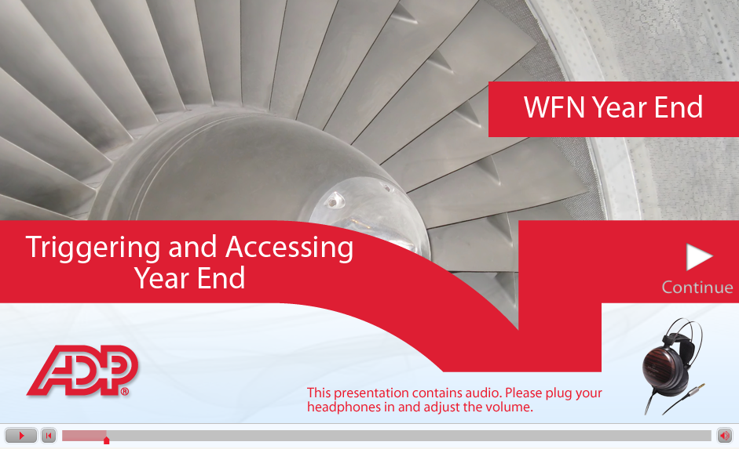
Screen 1: Introduction to Module – Screenshot
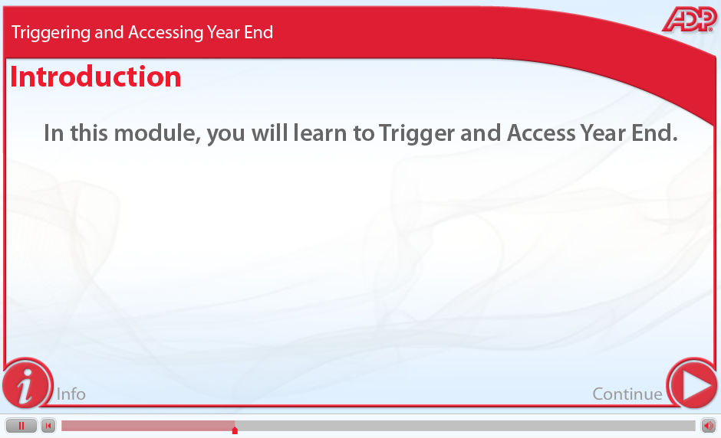
Screen 2: Introduction to Module 2 – Screenshot
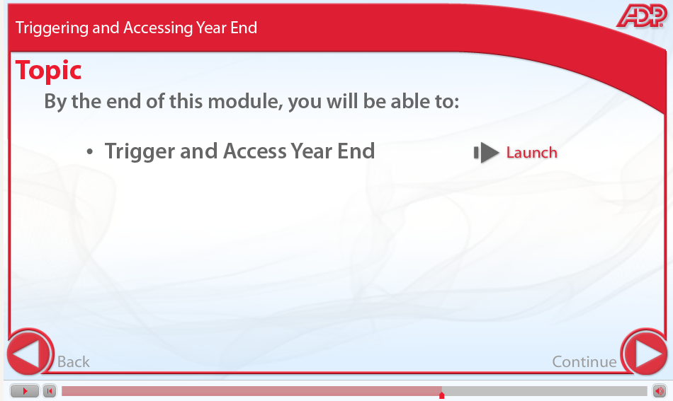
Screen 3: Introduction to Topic in Module – Screenshot
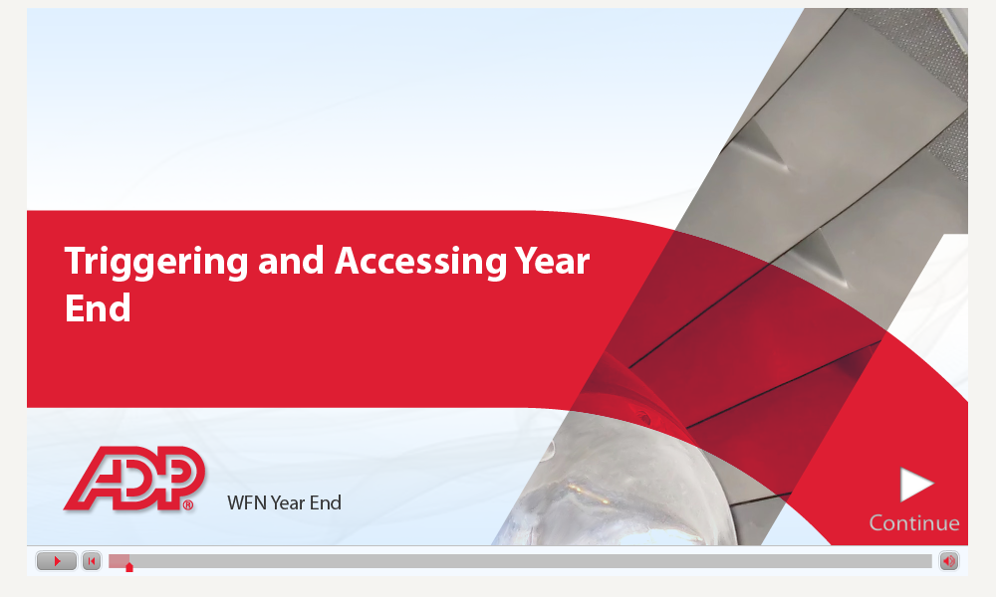
Screen 4: Introduction to Topic – Screenshot

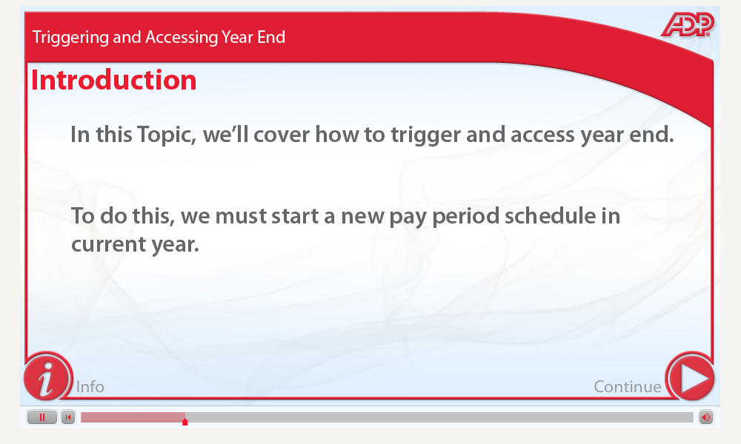
Screen 5: Introduction to Topic 2 – Screenshot

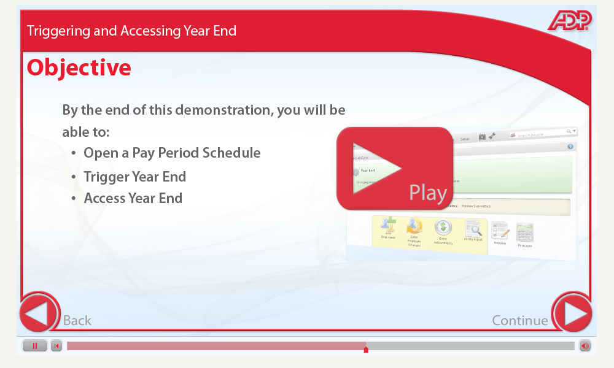
Screen 6: Launch Simulation in Topic – Screenshot
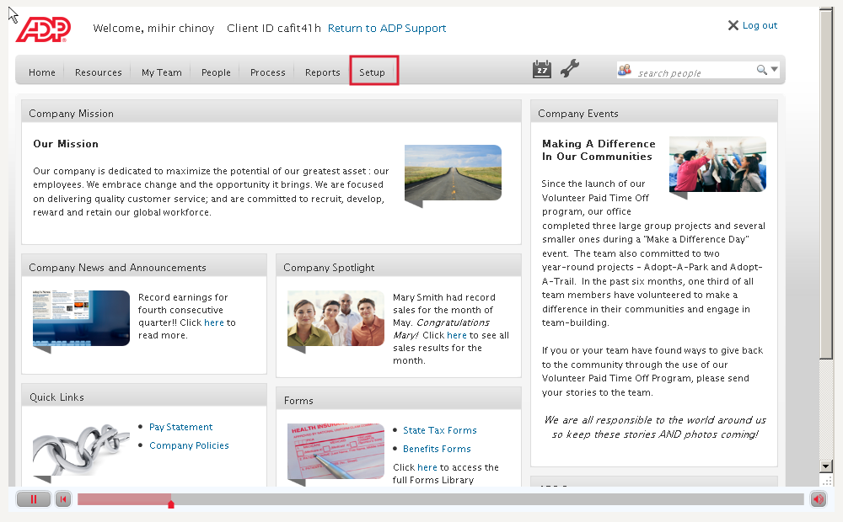
Screen 7: Simulation of Application – Screenshot
Source: ADP eLearning Course, 2012

Appendix C
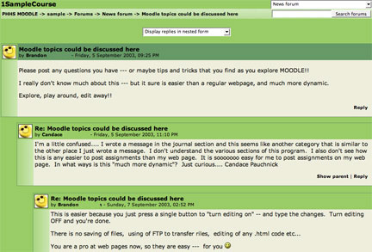
Source: Sample Discussion Forum (Example of Moodle Discussion forum, 2006)

